Supporting Information for “Observation of robust magnetic order in monolayer NiPS₃”
Lili Hu^{1,2†}, Hao-Xin Wang^{3†}, Yuzhong Chen¹, Kang Xu², Ming-Rui Li³, Haiyun Liu¹, Peng Gu¹, Yubin Wang², Mengdi Zhang¹, Hong Yao^{3,2}, Qihua Xiong^{1,2,4,5*}
¹ Beijing Academy of Quantum Information Sciences, Beijing 100193, P.R. China
² State Key Laboratory of Low-Dimensional Quantum Physics and Department of Physics, Tsinghua University, Beijing 100084, P.R. China
³ Institute for Advanced Study, Tsinghua University, Beijing 100084, China
⁴ Frontier Science Center for Quantum Information, Beijing, P.R. China
⁵ Collaborative Innovation Center of Quantum Matter, Beijing, P.R. China

Contents:
Supplementary Note I.
Raman tensor analysis for XX, XY, RL and RR polarizations.
Supplementary Note II.
Ultrafast spectroscopy with pump=385 nm, probe=510 nm and 560 nm.
Supplementary Note III.
DMRG results of the J₁-J₂-J₃-D model on YC6-cylinder.
Supplementary Note IV.
Single ion anisotropy dependence of the transition temperature

Supplementary Note I. Raman tensor analysis for XX, XY, RL and RR polarizations.

NiPS₃ is a qusi-two-dimensional layered material with interlayer van der Waals interaction much weaker than the intralayer covalent interaction. In addition, for magnetic structures of NiPS₃, the out-of-plane exchange interaction is too small compared with in-plane exchange interaction (Phys. Rev. B 102, 085408). Thus the spin structure is also quasi-two-dimensional. Monolayer NiPS₃ has D_{3d} symmetry. So we mainly consider describing the NiPS₃ samples by D_{3d} point group. There are two Raman active irreducible representations for D_{3d} group, Ag and Eg. The Eg modes are doubly degenerated, denoted as Eg(1) and Eg(2). The Raman tensors of Eg(1) and Eg(2) can be written as $α_{Eg(1)}= \left(\begin{matrix}c & 0 & 0 \\ 0 & -c & d \\ 0 & d & 0\end{matrix}\right) and α_{Eg(2)}=\left(\begin{matrix}0 & -c & -d \\ -c & 0 & 0 \\ -d & 0 & a\end{matrix}\right)$. The Raman tensor of Ag modes can be written as $α_{Ag}=\left(\begin{matrix}b & 0 & 0 \\ 0 & b & 0 \\ 0 & 0 & a\end{matrix}\right)$.The polarized light can be described by Jones vectors. For horizontally and vertically polarized light, there is X=$\left(\begin{matrix}1 \\ 0 \\ 0\end{matrix}\right)$ and Y=$\left(\begin{matrix}0 \\ 1 \\ 0\end{matrix}\right).$Right-handed and left-handed polarized light can be written as R=$\left(\begin{matrix}1 \\ -i \\ 0\end{matrix}\right)$ and L=$\left(\begin{matrix}1 \\ i \\ 0\end{matrix}\right).$The intensities of a specific Ag phonon measured at XX, XY, RL and RR polarization configurations are
$I_{XX}^{Ag}={\left|{X^{†}α}_{Ag}X\right|}^{2}$=$b^{2}$
$I_{XY}^{Ag}={\left|{X^{†}α}_{Ag}Y\right|}^{2}$=0
$I_{RL}^{Ag}={\left|{R^{†}α}_{Ag}L\right|}^{2}$=0
$I_{RR}^{Ag}={\left|{R^{†}α}_{Ag}R\right|}^{2}$=$b^{2}$
The intensities of a specific Eg phonon measured at XX, XY, RL and RR polarization configurations are
$I_{XX}^{Eg}={\left|{X^{†}α}_{Eg(1)}X\right|}^{2}+{\left|{X^{†}α}_{Eg(2)}X\right|}^{2}$=$c^{2}$
$I_{XY}^{Eg}={\left|{X^{†}α}_{Eg(1)}Y\right|}^{2}+{\left|{X^{†}α}_{Eg(2)}Y\right|}^{2}$=$c^{2}$
$I_{RL}^{Eg}={\left|{R^{†}α}_{Eg(1)}L\right|}^{2}+{\left|{R^{†}α}_{Eg(2)}L\right|}^{2}$=2$c^{2}$
$I_{RR}^{Eg}={\left|{R^{†}α}_{Eg(1)}R\right|}^{2}+{\left|{R^{†}α}_{Eg(2)}R\right|}^{2}$=$0$
Therefore, the Raman modes appearing only in XX and RR polarization configurations belong to Ag symmetry. The Eg modes appear only in XX, XY and RL polarization configurations.

Supplementary Note II. Ultrafast spectroscopy with pump=385 nm, probe=510 nm and 560 nm.

Fig. S1. Ultrafast spectroscopy investigation of NiPS₃ with pump=385 nm, probe=510 nm and 560 nm.

Supplementary Note III. DMRG results of the J₁-J₂-J₃-D model on YC6-cylinder.

In order to convince the reader about the zig-zag ground state for the J₁-J₂-J₃-D model, we show the results on YC6-cylinder as a complement to those on XC6-cylinder in the main text. Figure S2 (a) shows the in-plane spin correlations in a YC6-cylinder with $L_{x}=12$, where the purple cross is the reference point. The red arrows represent positive correlations, while the blue arrows represent negative ones. The spin correlations exhibit zig-zag order along the legs of the cylinder, and they almost do not decay in the central half of the cylinder. We also calculate the sublattice structure factor in Fig. S2 (b). The peak occurring at the M-point in the first Brillion zone confirms the zig-zag order. It gives the anti-ferromagnetic magnetization of $\sqrt{M^{2}\left(Q\right)}=0.75$, close to that on XC6-cylinder.
Fig. S2. Zig-zag ground state for the J₁-J₂-J₃-D model on YC6-cylinder. (a) in-plane spin correlation. (b) sublattice spin structure factor.

Supplementary Note IV. Single ion anisotropy dependence of the transition temperature
In the main text we choose the SIA $D=0.113meV$ which comes from the DFT calculation (cite 1). Different value $D≃1.1meV$ is also suggested in previous molecular-field theory analysis (cite 2). Here, we perform Monte Carlo simulations with different value of D to investigate the single ion anisotropy dependence of the transition temperature. We show the stiffness data in Figure S3. For $D=0.3 meV$ [Fig. S3 (a)], the transition temperature is about 143.6 K. While for $D=1 meV$ [Fig. S3 (b)], the transition temperature is about 150.1 K. Although D increases from 0.1 meV to 1 meV, the transition temperature only increases by about 10 K. We therefore conclude that the transition temperature does not strongly depend on the value of D.
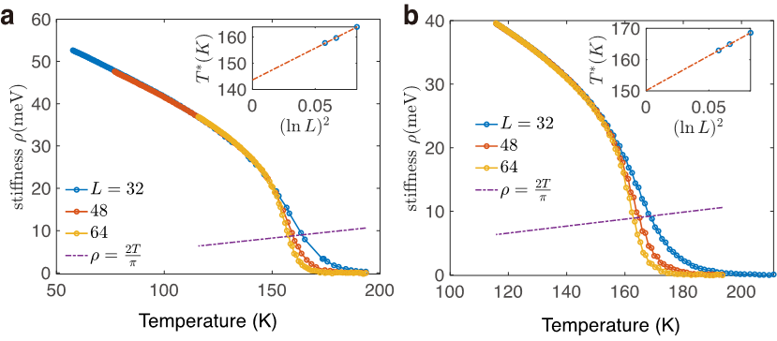
Fig. S3. The spin stiffness v.s. temperature for the J₁-J₂-J₃-D model with (a) $D=0.3 meV$, (b) $D=1 meV$. The insets: the finite-size extrapolations for the transition temperature.

Reference

- Magnetic anisotropy and Magnetic Ordering of Transition-Metal Phosphorus Trisulfides, Tae Yun Kim and Cheol-Hwan Park, Nano Letter 2021, 21, 10114-10121
- Magnetism in the layered transition-metal thiophosphates MPS3 (…), P.A. Joy and S. Vasudevan, PRB 1992

